**1st Assignment** : Add one attribute (age) in customer registration form and save it in DB

Step 1:

* Create an extension is the firstly
* Than create an attribute named AGE1

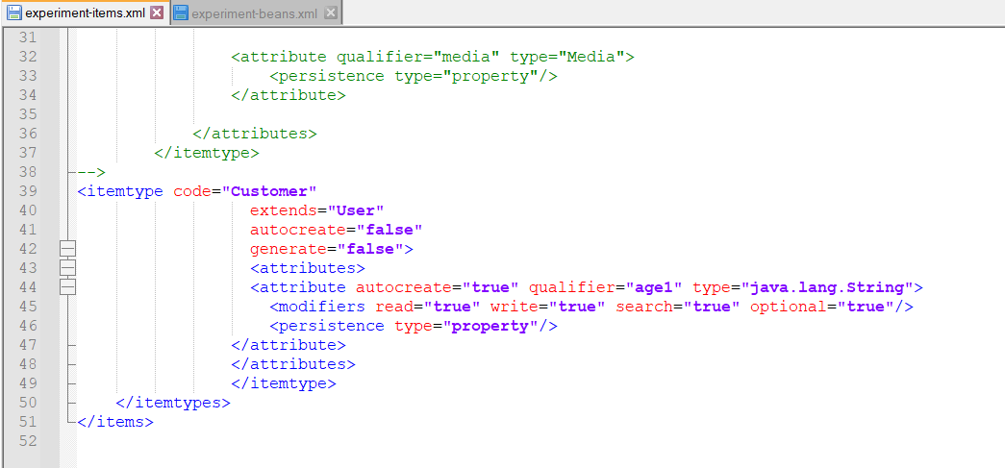

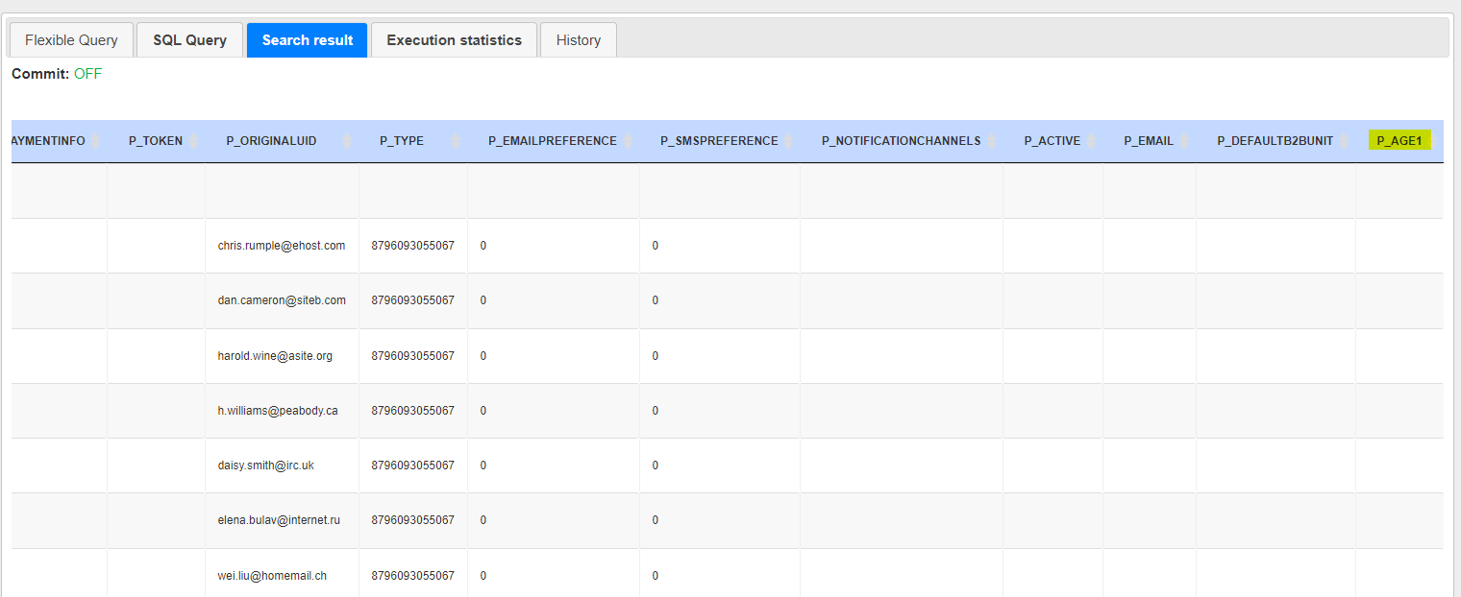

Age1 attribute is created in DB

Here we add value of age1 in back office through administration

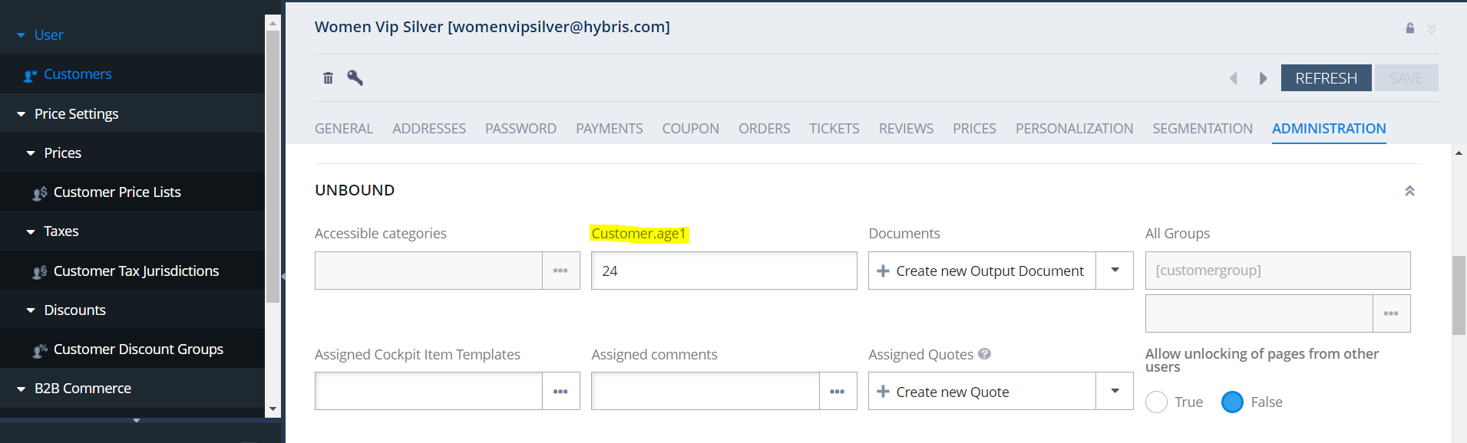

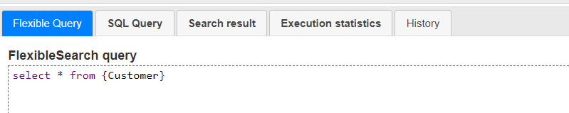

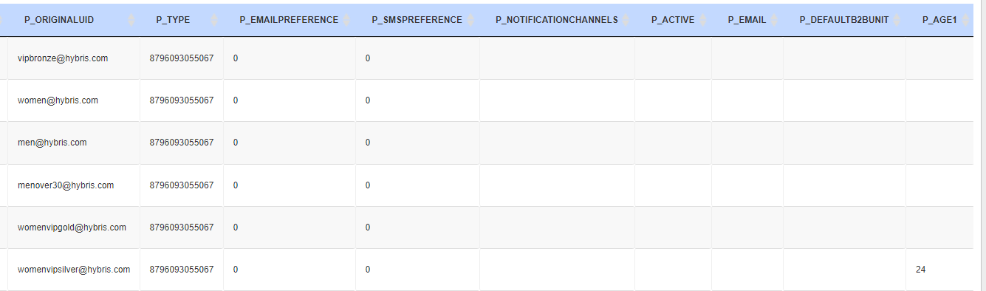

Now we have retrieved value of our attribute through HAC

Step 2 :

* Now create attribute in customer data.
* Data transfer object is there to show the attribute in front end.

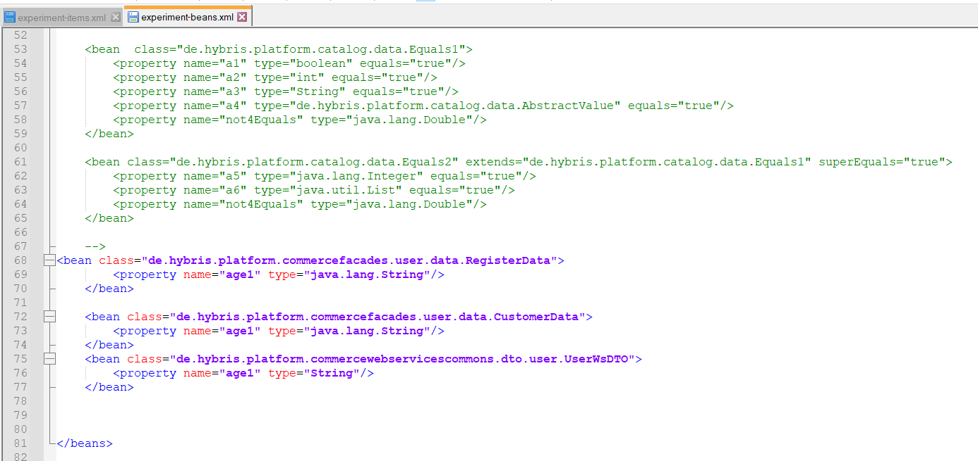

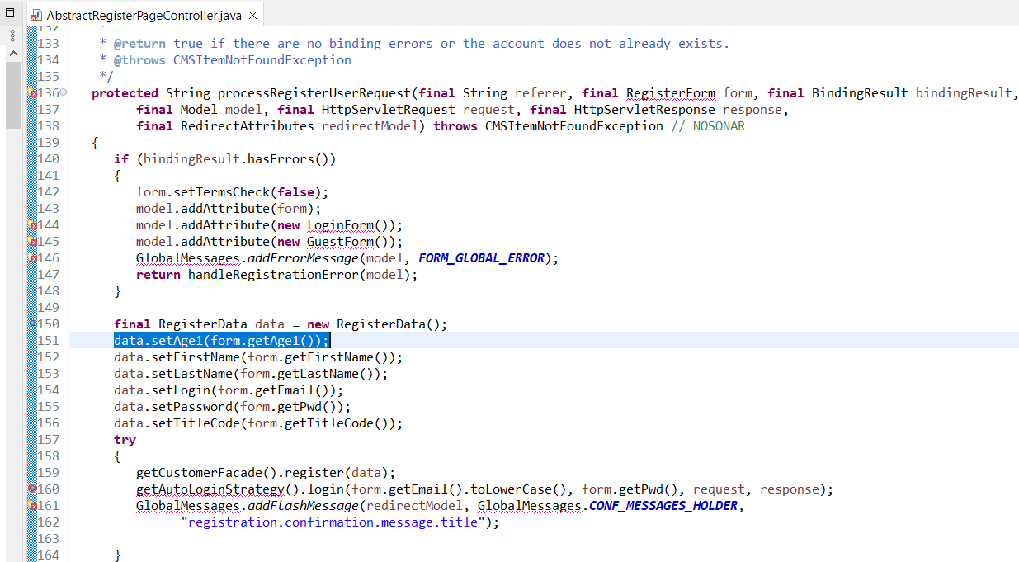

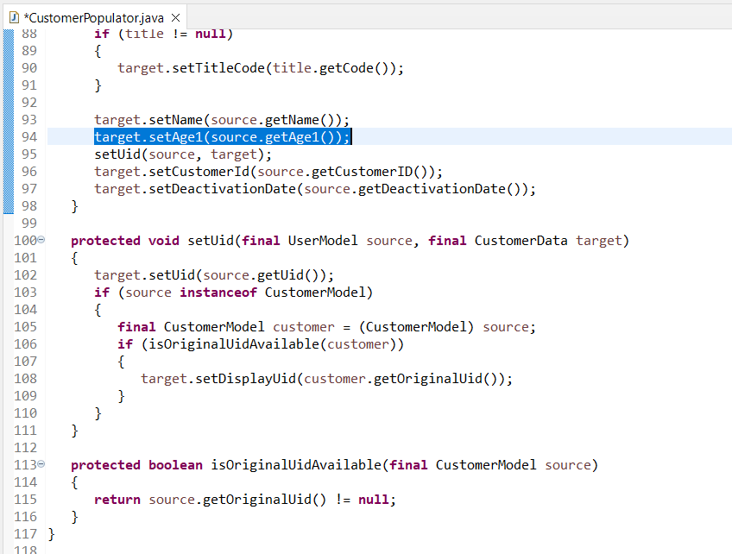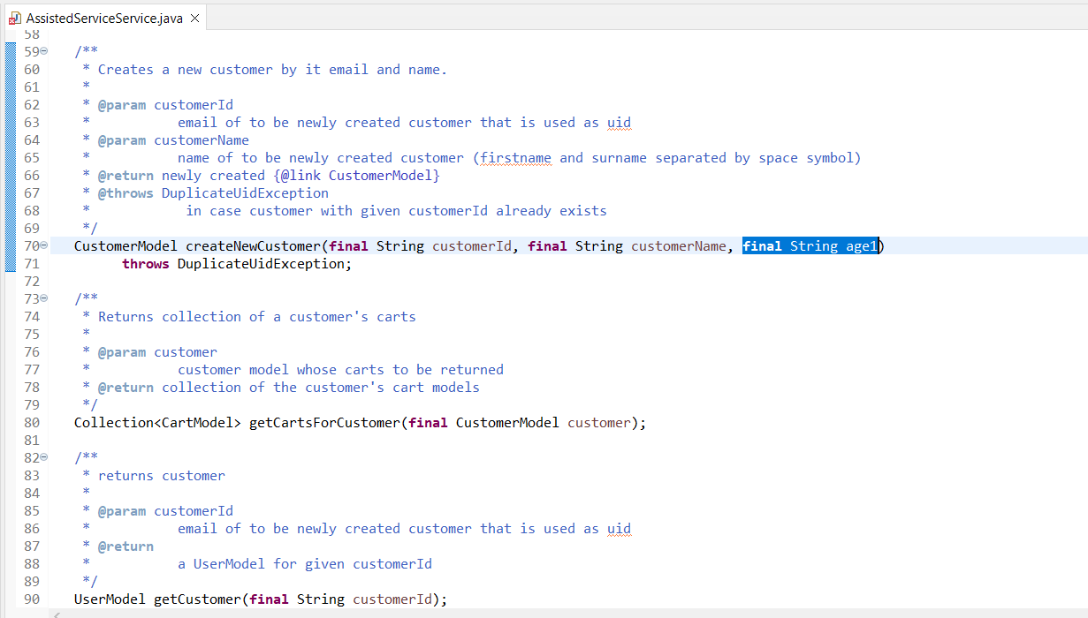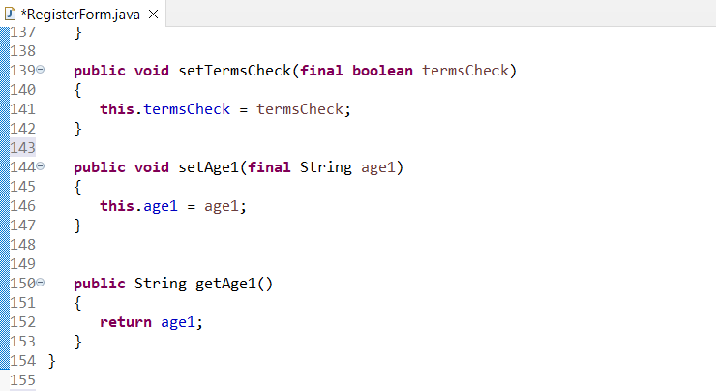

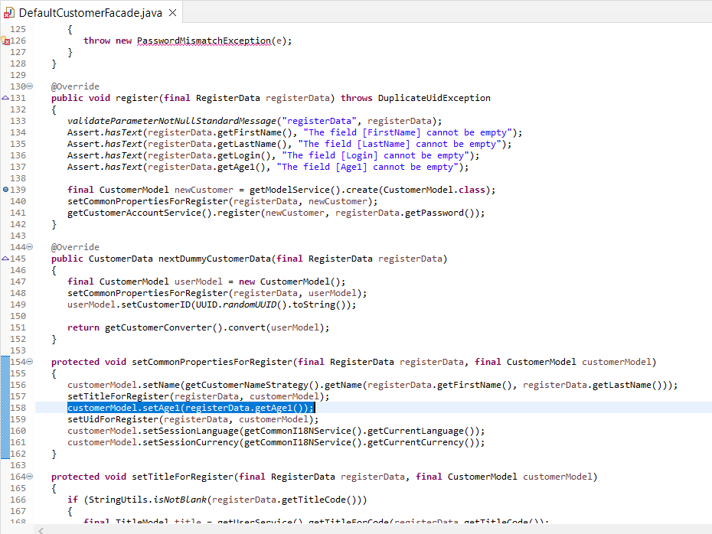

JSP File:

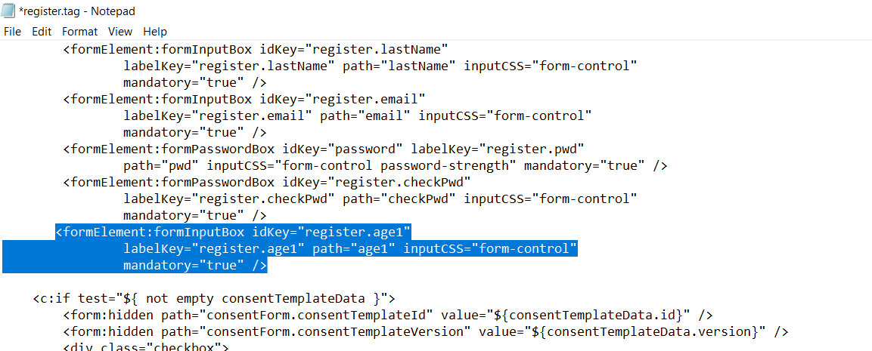

Final Result:

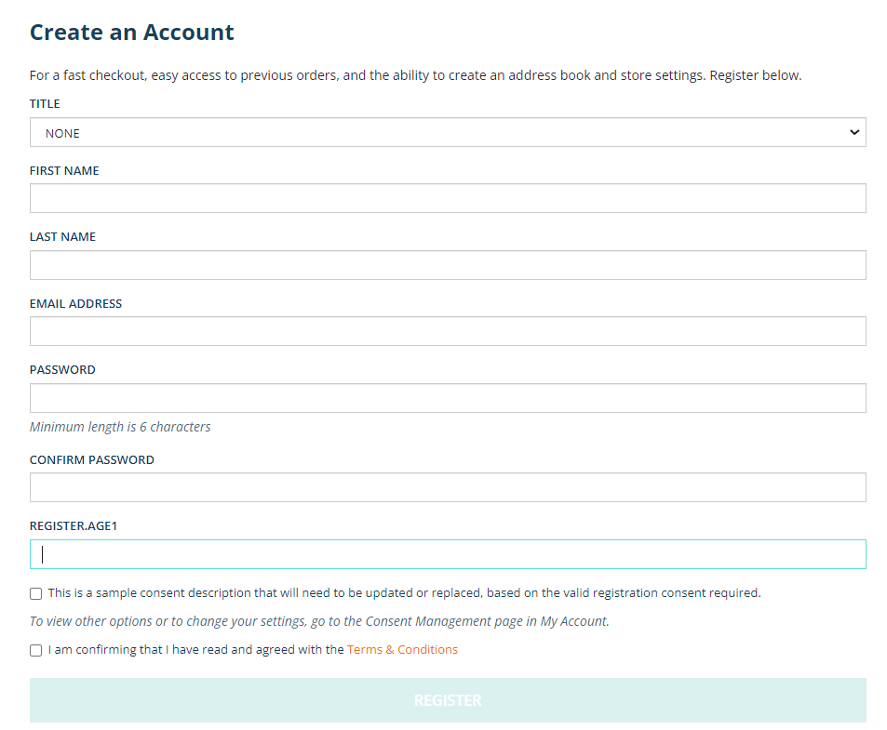

Finally Age1 gets added in registration form.